亚马逊开门板模拟工具V1.0
用户安装使用手册
User Manual of the Simulation Tool for Amazon Door Control Board
V1.0

http://www.szzhilai.com
中国 深圳 南山区 学苑大道南山智园C3栋15楼
15F, Building C3, Nanshan iPark, Xueyuan Blvd, Nanshan District, Shenzhen, China
Email：info@zhilai.com

深圳市智莱科技股份有限公司
Shenzhen Zhilai Sci and Tech Co., Ltd.
版权说明
Copyright statement

本手册以及相关的计算机软件程序仅用于为深圳智莱科技的最终用户提供信息，深圳智莱科技有限公司拥有所有权。本手册是深圳智莱科技有限公司的专有信息，并受中华人民共和国版权法和国际公约的保护。
未得到深圳智莱科技有限公司明确的书面许可，不得为任何目的、以任何形式或手段辅助或传播本手册的任何部分内容。
本手册内容若有变动，恕不另行通知。本手册中例子中所引用的公司、人名和数据若非特殊说明，均属虚构。
本手册以及本手册所提及的任何产品的使用均受适应的最终用户许可协议限制。本手册由深圳智莱科技有限公司制作。
This manual and related computer software programs are only used to provide information to the end users of Shenzhen Zhilai Sci and Tech Co., Ltd.. This manual is copyrighted by Shenzhen Zhilai Sci and Tech Co., Ltd. and is protected by Copyright Law of the People's Republic of China and Universal Copyright Convention.
No part of this manual may be transmitted in any form or by any means for any purpose without the written permission of Shenzhen Zhilai Sci and Tech Co., Ltd.
The contents of this manual are subject to change without notice. The company, person's name and data cited in the examples in this manual are fictitious unless otherwise stated.
The use of this manual and any products mentioned in this manual are subject to the applicable end user license agreement. This manual was made by Shenzhen Zhilai Sci and Tech Co., Ltd.

目录Contents
目录Contents 4
1关于本手册About this manual 5
1.1编写目的Purpose of writing 5
1.2软件环境Software 5
2安装配置Installation configuration 5
2.1安装jdk /Install jdk 5
2.1.1下载jdk/ Download jdk 5
2.1.2登录Linux /Log in to Linux 6
2.1.3建立java安装目录Create a java installation directory 6
2.1.4将jdk解压到安装目录Extract jdk to the installation directory 7
2.1.5配置环境变量Configuring environment variables 7
2.1.6生效查看View 7
2.2 tomcat安装Tomcat installation 7
2.2.1下载tomcat /Download tomcat 7
2.2.1建立安装目录Create an installation directory 8
2.2.3解压Decompression 8
2.3 工具软件安装Tool software installation 8
2.3.1文件复制File copy 8
2.3.2启动tomcat /Start tomcat 8
2.3.3修改参数配置Modify parameter configuration 9
2.3.4虚拟网口Virtual network port 10
2.3.5重启tomcat /Restart tomcat 10
2.3.6浏览器访问Browser access 11
3操作指引Operating guidelines 11
2.1开门板信息配置Door control board information configuration 11
2.2保存配置Save configuration 13
2.3UDP服务启动和关闭UDP service startup and shutdown 13
2.4日志打印Log printing 14
2.5修改箱子状态Modify box status 14

1关于本手册About this manual

1.1编写目的Purpose of writing
本文档主要针对用户如何安装和使用亚马逊开门板模拟工具而编写，文档适合于软件的开发人员、使用人员进行阅读。
This document is written for users on how to install and use the Amazon door control board simulation tool. The documentation is suitable for software developers and users to read.

1.2软件环境Software
操作系统：Linux系统、Mac OS
浏览器：Google Chrome、Firefox
jdk：jdk1.7+
web服务器：apache-tomcat-7+
Operating system: Linux, Mac OS
Browser: Google Chrome, Firefox
Jdk:jdk1.7+
Web server: apache-tomcat-7+

2安装配置Installation configuration

2.1安装jdk /Install jdk

2.1.1下载jdk/ Download jdk
从Oracle官网下载jdk，下载地址https://www.oracle.com/technetwork/java/javase/downloads/jdk8-downloads-2133151.html，根据操作系统位数选择对应的版本
Download jdk from Oracle official website, download the address https://www.oracle.com/technetwork/java/javase/downloads/jdk8-downloads-2133151.html, select the corresponding version according to the operating system bits.
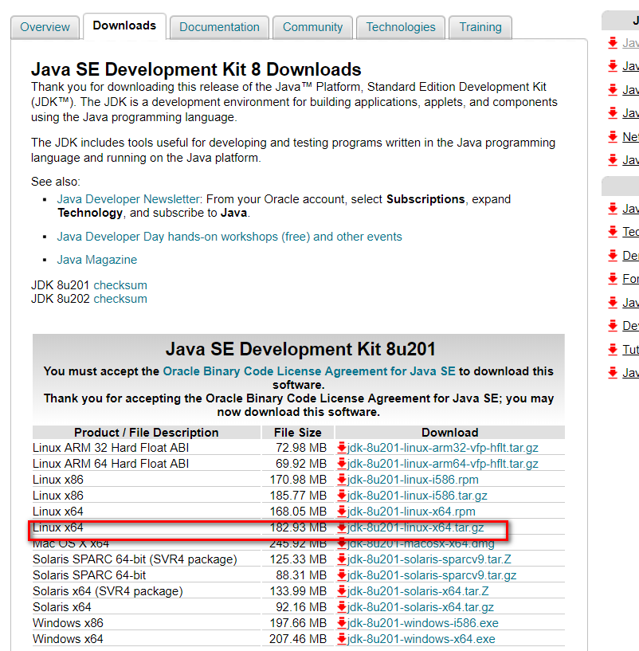

2.1.2登录Linux /Log in to Linux
su root 获取root用户权限
Su root to get root user rights

2.1.3建立java安装目录Create a java installation directory
cd /usr/lib
mkdir java

2.1.4将jdk解压到安装目录Extract jdk to the installation directory
tar -zxvf jdk-8u201-linux-x64.tar.gz

2.1.5配置环境变量Configuring environment variables
vim /etc/profile
添加以下内容，JAVA_HOME根据实际目录来写
Add the following. JAVA_HOME is written according to the actual directory
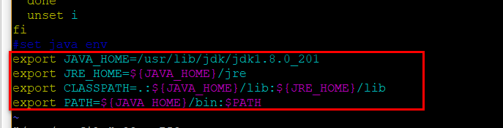

2.1.6生效查看View
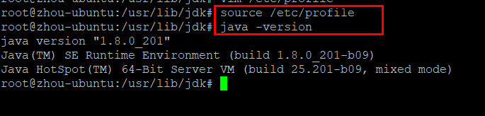

2.2 tomcat安装Tomcat installation

2.2.1下载tomcat /Download tomcat
下载地址：https://tomcat.apache.org/download-80.cgi
根据实际系统位数选择对应版本
Download address: https://tomcat.apache.org/download-80.cgi
Select the corresponding version based on the actual system bits

2.2.1建立安装目录Create an installation directory
cd /usr
mkdir tomcat

2.2.3解压Decompression
tar -zxvf apache-tomcat-8.5.37.tar.gz

2.3 工具软件安装Tool software installation

2.3.1文件复制File copy
将pcbTool-V1.0.0.1.war复制到tomcat的webapps目录下
Copy pcbTool-V1.0.0.1.war to the webapps directory of tomcat
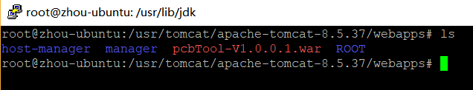

2.3.2启动tomcat /Start tomcat
切换到tomcat的bin目录启动tomcat，pcbTool-V1.0.0.1.war将自动解压
Switch to the tomcat bin directory to start tomcat. pcbTool-V1.0.0.1.war will automatically decompress
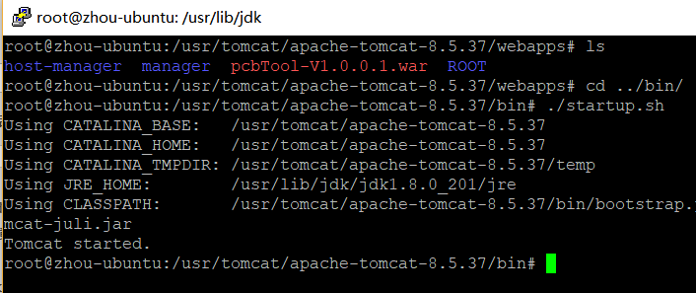
然后关闭tomcat，进入webapps目录可看到pcbTool-V1.0.0.1.war已解压为pcbTool-V1.0.0.1
Then close tomcat, enter the webapps directory and you can see that pcbTool-V1.0.0.1.war has been decompressed into pcbTool-V1.0.0.1
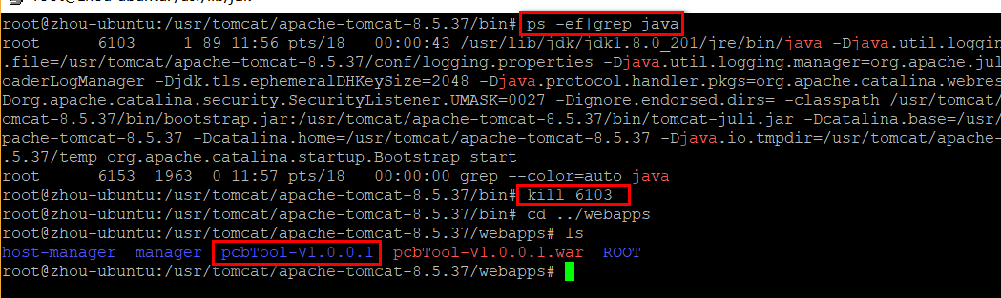
重命名文件夹pcbTool-V1.0.0.1为pcbTool
Rename the folder pcbTool-V1.0.0.1 to pcbTool
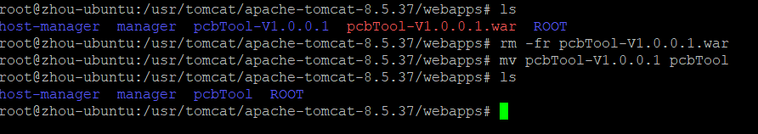

2.3.3修改参数配置Modify parameter configuration
如果前面tomcat的安装目录和文档默认的不一致，就需要修改jdbc.properties文件，相对tomcat位置为apache-tomcat-8.5.37/webapps/pcbTool/WEB-INF/classes/conf/jdbc.properties
If the previous tomcat installation directory is inconsistent with the documentation by default, you need to modify the jdbc.properties file. The relative tomcat location is apache-tomcat-8.5.37/webapps/pcbTool/WEB-INF/classes/conf/jdbc.properties

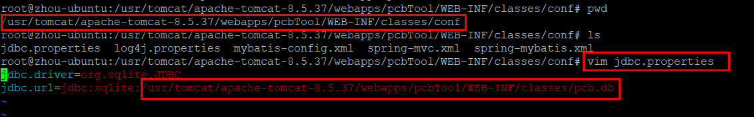
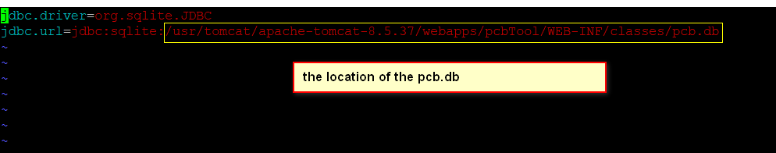

2.3.4虚拟网口Virtual network port
进入apache-tomcat-8.5.37/webapps/pcbTool/WEB-INF/classes目录，对创建网口脚本进行授权，并执行脚本优先创建网口，如果是Linux系统使用add_vir_eth.sh，如果是Mac系统则使用add_vir_mac.sh，命令如下：
./ add_vir_mac.sh 192.168.1.10 192.168.1.11
多个IP使用空格隔开即可
Go to the apache-tomcat-8.5.37/webapps/pcbTool/WEB-INF/classes directory, authorize the creation of the network port script, and execute the script to create the network port first. If your operating system is Linux please use add_vir_eth.sh, if your operating system is Mac OS please use add_vir_mac.sh .The commands are as follows:
./ add_vir_mac.sh 192.168.1.10 192.168.1.11
Multiple IPs can be separated by spaces

2.3.5重启tomcat /Restart tomcat
重复进入tomcat的bin目录启动tomcat
Re-enter the bin directory to start tomcat
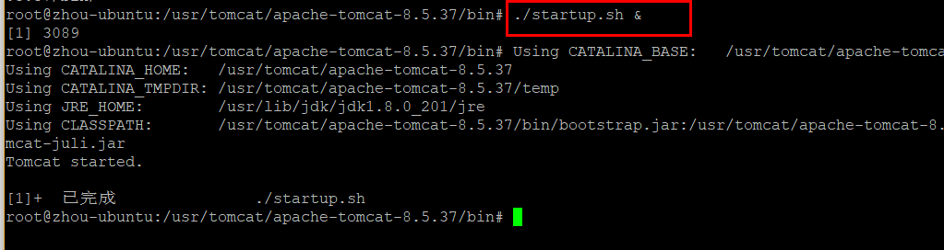

2.3.6浏览器访问Browser access
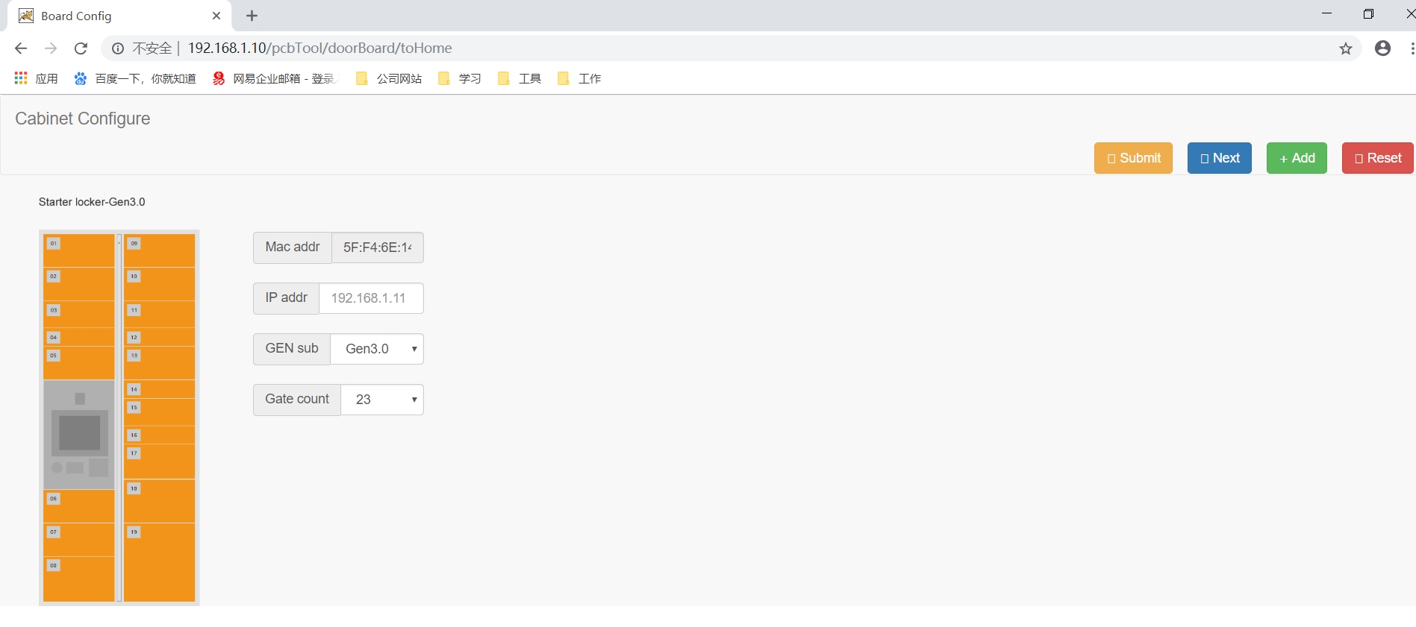

3操作指引Operating guidelines

3.1开门板信息配置Door control board information configuration
工具提供两种配置开门板的方式，用户可根据实际需求进行选择。第一种是手工配置（访问http://192.168.1.10/pcbTool/doorBoard/home），第二种是通过直接导入开门板的json格式配置数据（访问http://192.168.1.10/pcbTool/portal）。

3.1.1 手工配置
初次进入系统，界面默认显示一个主柜开门板，MAC地址是系统默认生成，随机且唯一。用户需要补充IP地址（这里一定要填写之前有虚拟网口的IP），当选择不同GEN后柜型将进行相应切换。
The first time you enter the system, the interface displays a starter door control board by default. The MAC address is generated by the system by default, which is random and unique. The user needs to add the IP address (must be the IP with a virtual network port). When different GEN is selected, the cabinet type will be switched accordingly.
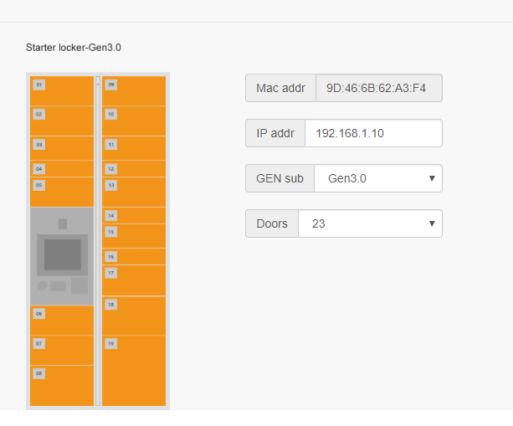
用户需要新增副柜开门板的时候可以点击右上角的按钮，副柜的GEN必须与主柜一致，无法修改。副柜开门板IP也需要填写对应的虚拟网口IP，摆放位置可根据需求进行选择。
When the user needs to add a new adder door control board, he can click the button in the upper right corner. The GEN of the adder must be the same as the starter and cannot be modified. The IP of the adder door control board also need to be the corresponding virtual network port IP, and the placed position can be selected according to demand.
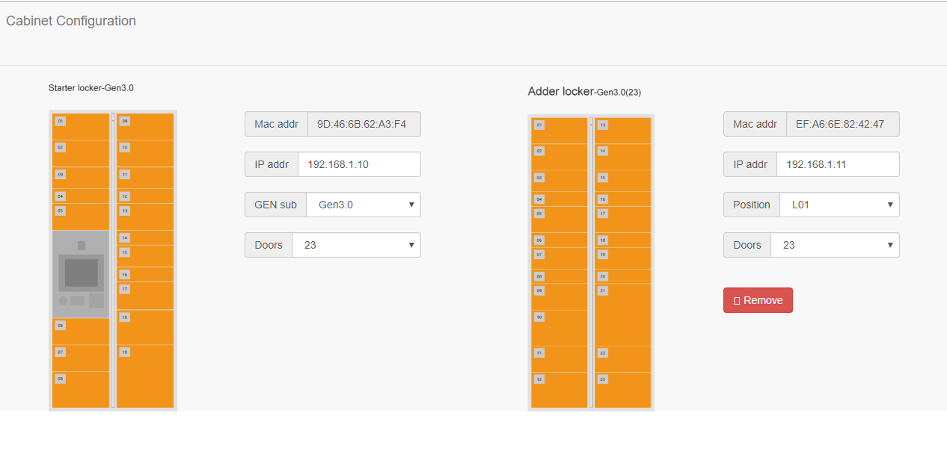
几个按钮功能说明：
Function description of several buttons:
提交开门板配置数据，进行保存；Submit door control board configuration data and save
当下次重新进入配置页面，但开门板配置信息不需要更新，且想要保留之前箱子状态数据时，可以直接Next进入下一步；When you re-enter the configuration page next time, and there is no need to update the door control board configuration information, still you want to retain the previous box status data, you can go directly to the next step.
新增一个副柜；Add an adder locker
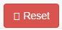重置信息，之前的开门板信息会全部清空。Reset and clear all previous information about door control board.

3.1.2 JSON文件导入配置
在浏览器地址栏输入http://192.168.1.10/pcbTool/portal进入系统（图一）需要导入JSON文件，只支持txt文本文件，第一步点击按钮，然后选择对应的需要导入的文本文件，导入成功后跳转到开门板箱子状态信息页（图二）。
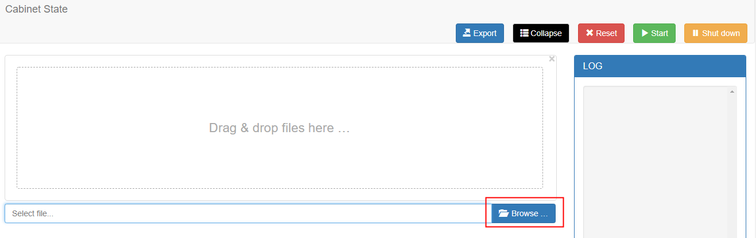
（图一）

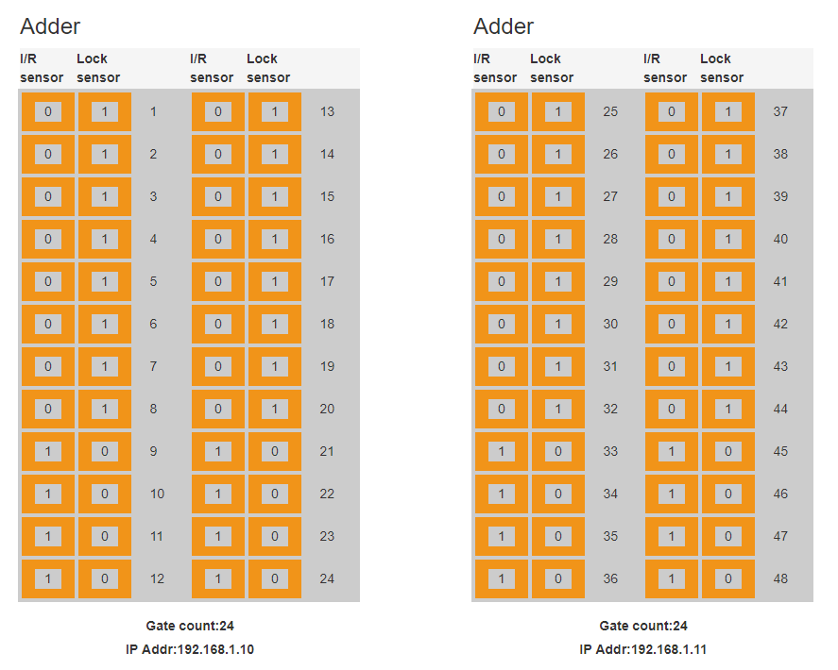
（图二）

3.2保存配置Save configuration
开门板配置信息填写完毕后，单击右上角的按钮，进入开门板箱子状态信息页：
After the configuration information is filled in, click the submit button in the upper right corner to enter the box status page.
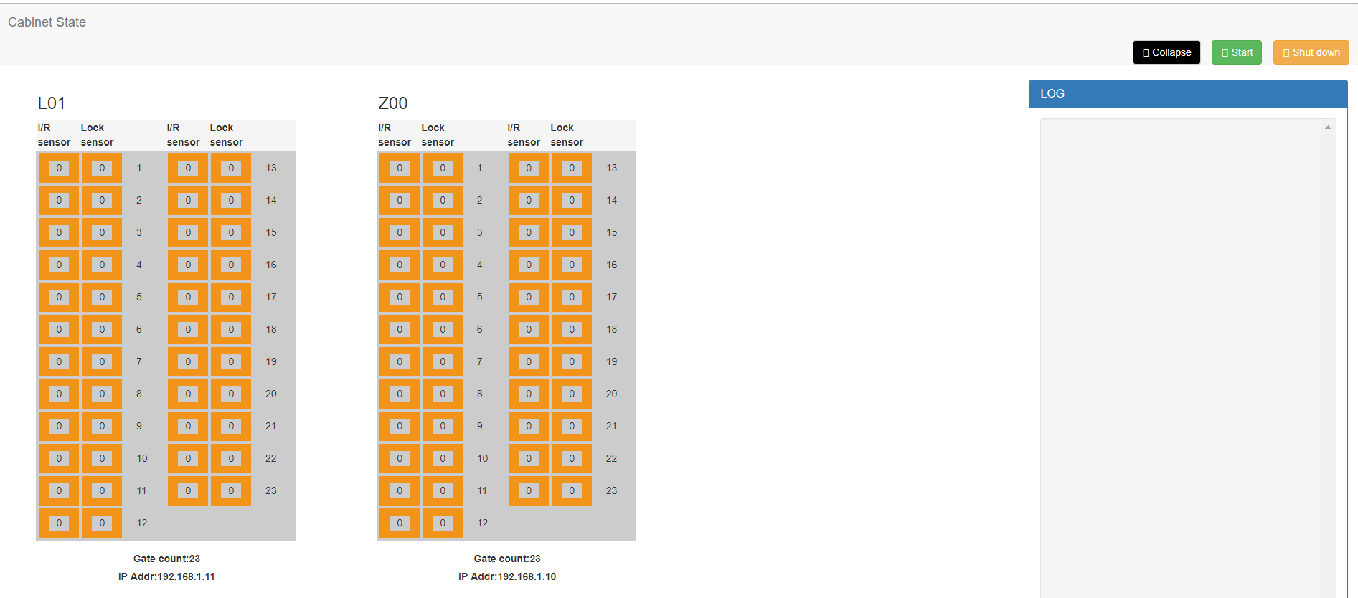

3.3UDP服务启动和关闭UDP service startup and shutdown
单击按钮，会启动所配置的开门板服务，只有服务启动后才能进行开门板通讯协议模拟测试工作；Click the start button to start the configured door control board service, and only when the service is started can the protocol simulation test be performed.

单击按钮，可以关闭开门板服务
Click Shut down to shut down the service

3.4日志打印Log printing
当上位机给指定开门板发送协议后，协议信息将展示在右侧日志窗口中，便于测试人员查看收发协议是否存在问题。
After the host computer sends the protocol to the specified door control board, the protocol information will be displayed in the log window on the right side, which is convenient for the tester to check whether there is any problem with the protocol.
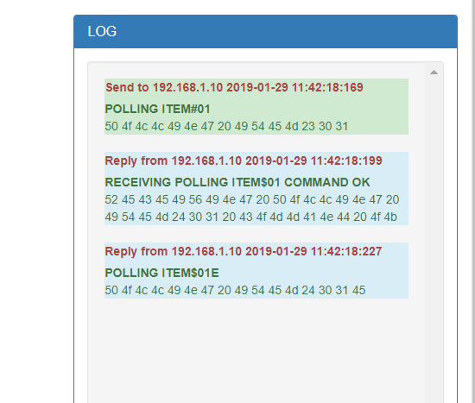

3.5修改箱子状态Modify box status
操作人员可以使用鼠标点击对应箱的I/R sensor和Lock sensor，分别修改光耦状态和锁状态。
对于光耦状态，显示“0”的话，表示空箱，显示“1”表示有物；
对于锁状态，显示“0”的话，表示门关闭，显示“1”表示门打开；
The operator can use the mouse to click the I/R sensor and Lock sensor of the corresponding box to modify the sensor status and lock status respectively.
For the sensor status, "0" means empty box, and "1" means that it is occupied;
For the lock status, "0" means the door is closed, and "1" indicates that the door is open.
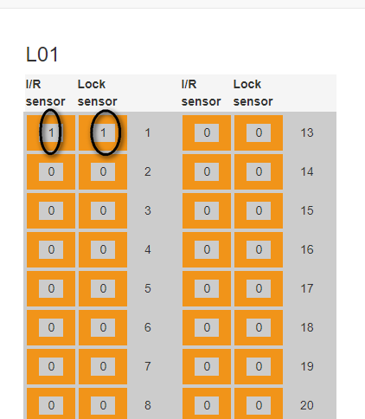

3.6 导出配置
点击当前页面按钮到处当前箱子信息，到处数据为文本格式，数据为JSON格式。
注意：如果在导出配置后日志打印失效，可以手动刷新下页面。

